JEREMY SCOTT FITNESS CHARITY SESSION
COME SPRINT WITH US AND RAISE MONEY FOR PROSTATE CANCER REASEARCH
SEPTEMBER IS NATIONAL PROSTATE CANCER MONTH AND WE WANT TO SHOW OUR SUPPORT HERE TOO. Prostate cancer is the most common cancer among men in the United States.

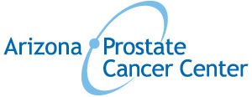

WHERE: CACTUS PARK
WHEN: 8 AM
COST: DONATION OF YOUR CHOICE
WHEN: SUNDAY SEPTEMBER 28, 2014
All donations go to Arizona Prostate Cancer Center

